BI SECURITY – SECURITY RECOMMENDATION REPORT

1. Objective
To design a secure access strategy for Global Superstore reports using authentication, authorization, role-based permissions and Row-Level Security (RLS).

2. User Roles and Access Requirements
The CEO needs overall business performance information. The Sales Manager needs sales and customer information. The Finance Manager needs revenue and profit information, while Regional Managers need data related to their assigned regions.

3. Authentication Analysis
Username-password authentication provides basic identity verification. Organizational accounts support centralized user management. Multi-Factor Authentication (MFA) adds another verification step and provides stronger protection against unauthorized account access.

4. Authorization and Access Control
Permissions were planned according to job responsibilities. General managers receive only the access needed for their work, while the BI Administrator receives permissions required to manage reports and security. This follows the principle of least privilege.

5. Row-Level Security Implementation
Two RLS roles were created in Power BI using the Dim_Region table. North_Manager uses the filter [Region] = "North Africa", while South_Manager uses [Region] = "Southern Asia". Both values are present in the dataset.
North_Manager test result:
Using View as, the Sales by Region visual displayed North Africa only. The dashboard showed total sales of approximately 233.16K and total profit of 57.83K.
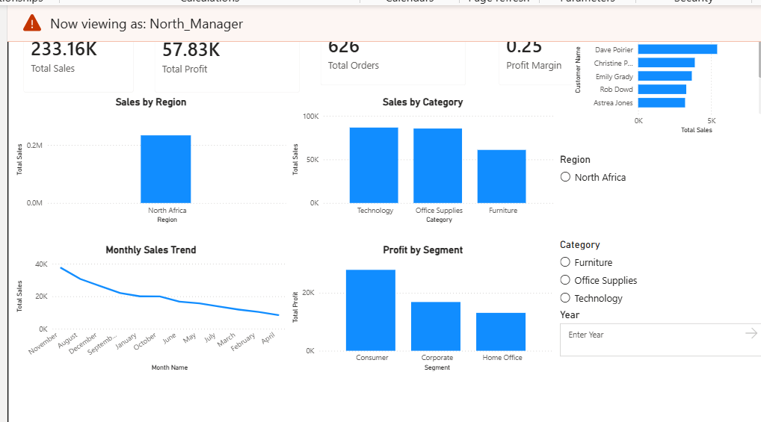
Figure 1: RLS test for North_Manager – North Africa data only.
South_Manager test result:
Using View as, the Sales by Region visual displayed Southern Asia only. The dashboard showed total sales of approximately 866.57K and total profit of 159.34K.
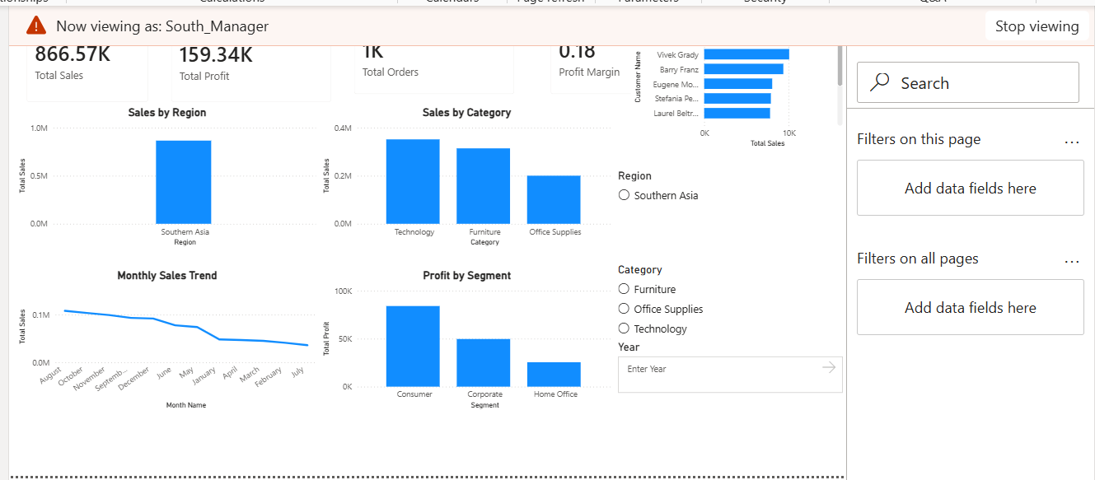
Figure 2: RLS test for South_Manager – Southern Asia data only.

6. Security Risk Assessment
Security Risk | Possible Impact | Mitigation
Unauthorized access | Exposure of business data | Use role-based permissions
Excessive permissions | Misuse or unwanted changes | Apply least privilege
Data leakage | Loss of confidentiality | Restrict report sharing
Weak authentication | Account compromise | Use strong passwords and MFA

7. Security Recommendations
- Use strong passwords and enable MFA for organizational accounts.
- Assign permissions according to each user's responsibilities.
- Give administrative access only to authorized BI administrators.
- Apply and test RLS to restrict regional data.
- Limit report sharing to approved users and groups.
- Review workspace access and permissions regularly.

8. Conclusion
A BI security strategy was designed using authentication, authorization and access control principles. Role-based permissions and two Row-Level Security roles were configured and tested successfully in Power BI Desktop. Common security risks were identified and suitable controls were recommended.

